January
2020
Planning Calendar
Living Faith Lutheran Church | 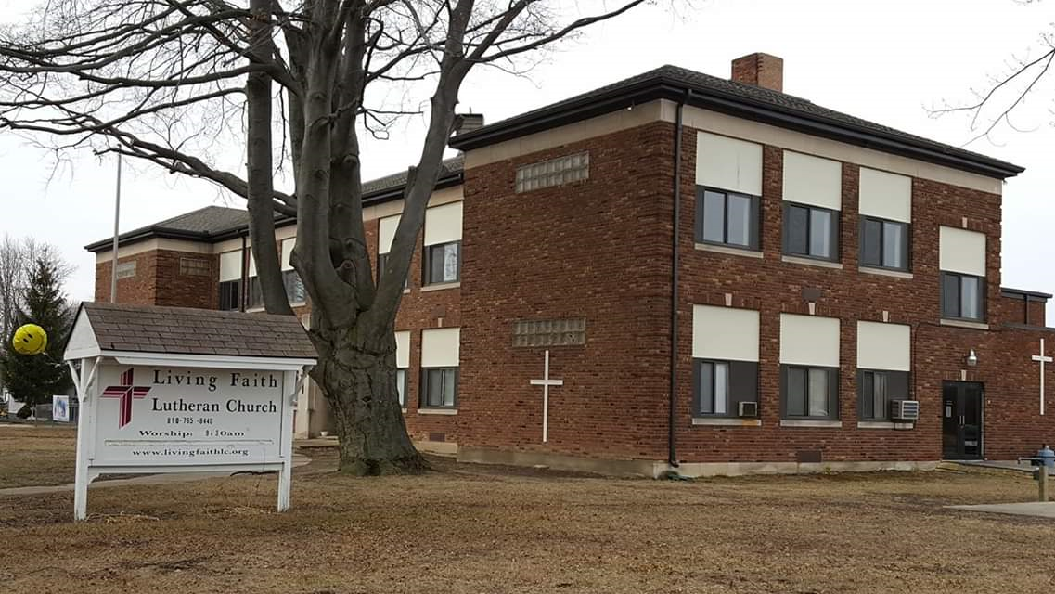
Sunday | Monday | Tuesday | Wednesday | Thursday | Friday | Saturday
 |  |  | 1 | 2 | 3 | 4
 |  |  | New Year’s Day
Epiphany 5 | 6 | 7 | 8 | 9 | 10 | 11
9:30 AM Worship  11 AM Bible Study |  |  | Locomotion  4:30 p m-6:00 pm
12 | 13 | 14 | 15 | 16 | 17 | 18
9:30 AM Worship  11 AM Bible Study |  |  | Locomotion  4:30 p m-6:00 pm |  |  | Life Line Screening 9 am-4:30 pm
19 | 20 | 21 | 22 | 23 | 24 | 25
9:30 AM Worship  11 AM Bible Study | MLK Day |  | Locomotion  4:30 p m-6:00 pm
26 | 27 | 28 | 29 | 30 | 31
9:30 AM Worship  11 AM Bible Study |  |  | Locomotion  4:30 p m-6:00 pm
February
2020
Planning Calendar

Living Faith Lutheran Church

Sunday | Monday | Tuesday | Wednesday | Thursday | Friday | Saturday
 |  |  |  |  |  | 1
2 | 3 | 4 | 5 | 6 | 7 | 8
9:30 AM Worship  11 AM Bible Study |  |  | Locomotion  4:30 p m-6:00 pm
9 | 10 | 11 | 12 | 13 | 14 | 15
9:30 AM Worship  11 AM Bible Study |  |  | Locomotion  4:30 p m-6:00 pm
16 | 17 | 18 | 19 | 20 | 21 | 22
9:30 AM Worship  11 AM Bible Study |  |  | Locomotion  4:30 p m-6:00 pm
23 | 24 | 25 | 26 | 27 | 28 | 29
9:30 AM Worship  11 AM Bible Study |  |  | Locomotion  4:30 p m-6:00 pm  Ash Wednesday Service 6 PM

March
2020
Planning Calendar

Living Faith Lutheran Church

Sunday | Monday | Tuesday | Wednesday | Thursday | Friday | Saturday
1 | 2 | 3 | 4 | 5 | 6 | 7
9:30 AM Worship  11 AM Bible Study |  |  | Locomotion  4:30 p m-6:00 pm
Lent 1 8 | 9 | 10 | 11 | 12 | 13 | 14
9:30 AM Worship  11 AM Bible Study |  |  | Locomotion  4:30 p m-6:00 pm
Lent 2 15 | 16 | 17 | 18 | 19 | 20 | 21
9:30 AM Worship  11 AM Bible Study |  |  | Locomotion  4:30 p m-6:00 pm
Lent 3 22 | 23 | 24 | 25 | 26 | 27 | 28
9:30 AM Worship  11 AM Bible Study |  |  | Locomotion  4:30 p m-6:00 pm
Lent 4 29 | 30 | 31
9:30 AM Worship
11 AM Bible Study

April
2020
Planning Calendar

Living Faith Lutheran Church

Sunday | Monday | Tuesday | Wednesday | Thursday | Friday | Saturday
 |  |  | 1 | 2 | 3 | 4
5 | 6 | 7 | 8 | 9 | 10 | 11
Palm Sunday  9:30 AM Worship  11 AM Bible Study |  |  | Locomotion  Easter Play Service 5:30 pm | Maundy Thursday 7 PM | Good Friday 7PM
12 | 13 | 14 | 15 | 16 | 17 | 18
Easter  9:30 AM Worship |  |  | Locomotion  4:30 p m-6:00 pm
19 | 20 | 21 | 22 | 23 | 24 | 25
9:30 AM Worship  11 AM Bible Study |  |  | Locomotion  4:30 p m-6:00 pm |  |  | PJ’s and Pancake Breakfast  10am-noon
26 | 27 | 28 | 29 | 30
9:30 AM Worship  11 AM Bible Study |  |  | Last day of Locomotion until September 2020  4:30 p m-6:00 pm

May
2020
Planning Calendar

Living Faith Lutheran Church

Sunday | Monday | Tuesday | Wednesday | Thursday | Friday | Saturday
 |  |  |  |  | 1 | 2
3 | 4 | 5 | 6 | 7 | 8 | 9
9:30 AM Worship  11 AM Bible Study |  |  | Locomotion  4:30 p m-6:00 pm
10 | 11 | 12 | 13 | 14 | 15 | 16
Mother’s Day  9:30 AM Worship  11 AM Bible Study |  |  | Locomotion  4:30 p m-6:00 pm
17 | 18 | 19 | 20 | 21 | 22 | 23
9:30 AM Worship
11 AM Bible Study

24 | 25 | 26 | 27 | 28 | 29 | 30
9:30 AM Worship  11 AM Bible Study | Memorial Day
31
9:30 AM Worship
11 AM Bible Study

June
2020
Planning Calendar

Living Faith Lutheran Church

Sunday | Monday | Tuesday | Wednesday | Thursday | Friday | Saturday
 | 1 | 2 | 3 | 4 | 5 | 6
7 | 8 | 9 | 10 | 11 | 12 | 13
9:30 AM Worship

14 | 15 | 16 | 17 | 18 | 19 | 20
9:30 AM Worship

21 | 22 | 23 | 24 | 25 | 26 | 27
Father’s Day
9:30 AM Worship

28 | 29 | 30
9:30 AM Worship

July
2020
Planning Calendar

Living Faith Lutheran Church

Sunday | Monday | Tuesday | Wednesday | Thursday | Friday | Saturday
 |  |  | 1 | 2 | 3 | 4
5 | 6 | 7 | 8 | 9 | 10 | 11
9:30 AM Worship

12 | 13 | 14 | 15 | 16 | 17 | 18
9:30 AM Worship

19 | 20 | 21 | 22 | 23 | 24 | 25
9:30 AM Worship

26 | 27 | 28 | 29 | 30 | 31
9:30 AM Worship

August
2020
Planning Calendar

Living Faith Lutheran Church

Sunday | Monday | Tuesday | Wednesday | Thursday | Friday | Saturday
 |  |  |  |  |  | 1
2 | 3 | 4 | 5 | 6 | 7 | 8
9:30 AM Worship  VBS Church Picnic (tentative) | V.B.S. | V.B.S. | V.B.S. | V.B.S. | V.B.S. | Maritime Days (tentative)
9 | 10 | 11 | 12 | 13 | 14 | 15
9:30 AM Worship
VBS Service with Church Picnic
16 | 17 | 18 | 19 | 20 | 21 | 22
9:30 AM Worship

23 | 24 | 25 | 26 | 27 | 28 | 29
9:30 AM Worship

30 | 31
9:30 AM Worship

September
2020
Planning Calendar

Living Faith Lutheran Church

Sunday | Monday | Tuesday | Wednesday | Thursday | Friday | Saturday
 |  | 1 | 2 | 3 | 4 | 5
6 | 7 | 8 | 9 | 10 | 11 | 12
9:30 AM Worship | Labor Day
13 | 14 | 15 | 16 | 17 | 18 | 19
9:30 AM Worship
11 AM Bible Study

20 | 21 | 22 | 23 | 24 | 25 | 26
9:30 AM Worship  11 AM Bible Study |  |  |  | BLAST  5 p.m.-7 p.m.
27 | 28 | 29 | 30
9:30 AM Worship
11 AM Bible Study

October
2020
Planning Calendar

Living Faith Lutheran Church

Sunday | Monday | Tuesday | Wednesday | Thursday | Friday | Saturday
 |  |  |  | 1 | 2 | 3
BLAST
5 p.m.-7 p.m.
4 | 5 | 6 | 7 | 8 | 9 | 10
9:30 AM Worship  11 AM Bible Study  Installation of Pastor Yanke |  |  |  | BLAST  5 p.m.-7 p.m.
11 | 12 | 13 | 14 | 15 | 16 | 17
9:30 AM Worship  11 AM Bible Study |  |  |  | BLAST  5 p.m.-7 p.m.
18 | 19 | 20 | 21 | 22 | 23 | 24
9:30 AM Worship  11 AM Bible Study |  |  |  | BLAST  5 p.m.-7 p.m.
25 | 26 | 27 | 28 | 29 | 30 | 31
9:30 AM Worship  11 AM Bible Study |  |  |  | BLAST  5 p.m.-7 p.m. |  | Trunk or Treat Tentative

November
2020
Planning Calendar

Living Faith Lutheran Church

Sunday | Monday | Tuesday | Wednesday | Thursday | Friday | Saturday
1 | 2 | 3 | 4 | 2 | 3 | 4
9:30 AM Worship  11 AM Bible Study |  |  |  | BLAST  5 p.m.-7 p.m.
8 | 9 | 10 | 11 | 9 | 10 | 11
9:30 AM Worship  11 AM Bible Study |  |  |  | BLAST  5 p.m.-7 p.m.
15 | 16 | 17 | 18 | 16 | 17 | 18
9:30 AM Worship  11 AM Bible Study |  |  |  | BLAST  5 p.m.-7 p.m.
22 | 23 | 24 | 25 | 23 | 24 | 25
9:30 AM Worship  11 AM Bible Study |  |  | 7 PM Thanksgiving Eve Service | Thanksgiving Day
Advent 1 29 | 30 | 31 |  | 30 | 31
9:30 AM Worship |  |  |  | BLAST  5 p.m.-7 p.m.

December
2020
Planning Calendar

Living Faith Lutheran Church

Sunday | Monday | Tuesday | Wednesday | Thursday | Friday | Saturday
 |  | 1 | 2 | 3 | 4 | 5
BLAST
5 p.m.-7 p.m.
Advent 2 6 | 7 | 8 | 9 | 10 | 11 | 12
9:30 AM Worship  11 AM Bible Study |  |  |  | BLAST  5 p.m.-7 p.m.
Advent 3 13 | 14 | 15 | 16 | 17 | 18 | 19
9:30 AM Worship  11 AM Bible Study |  |  |  | BLAST  5 p.m.-7 p.m.
Advent 4 20 | 21 | 22 | 23 | 24 | 25 | 26
9:30 AM Worship  11 AM Bible Study |  |  |  | 7 PM Christmas Eve Service | Christmas
Sunday after Christmas 27 | 28 | 29 | 30 | 31
9:30 AM Worship |  |  |  | New Year’s Eve

